**Docker Compose**

It is used to run multi-container applications. Each container will run a stand-alone application and it can communicate with other containers present in the same host.

Example:- MEAN Stack Application [MongoDB, ExpressJS, Angular & NodeJS] using different containers.

**Docker-compose.yml file**

version ‘3.0’ #specify docker-compose version

# Define the services/containers to be run

services:

angular: # name of the first service

build: angular-app # directory of dockerfile

ports:

* “4200:4200” # specify port mapping

express: # name of second service

build: express-server # directory of Dockerfile

ports:

* “3000:3000” # port mapping

links:

* database # link service to db service

database: # name of third service

image: mongo # specify image to build container from

ports:

* ‘27017:27017’ # port forewarding

**Run Docker-compose file:**

docker-composefile up

**Docker Swarm:-**

It is a technique to create and maintain cluster of Docker Engines.

Service deployed in any node can be accessed on other nodes in the same cluster.

**Features:**

High-Availability of services

Auto load-balancing

Decentralized access

Easy to Scale-up deployments

Rolling updates

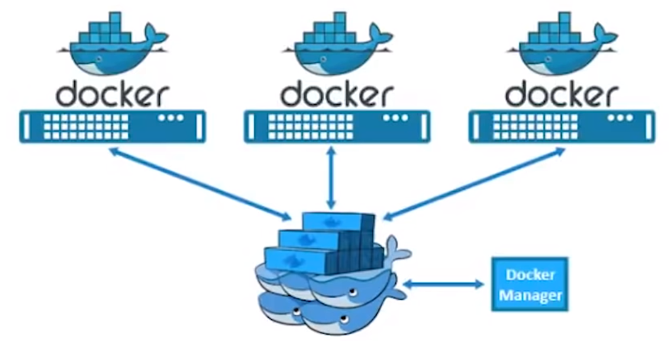

**Swarm commands:**

